Building Statistics
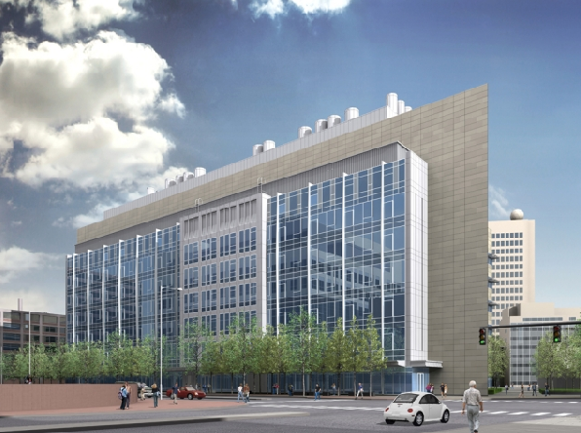
David H. Koch Institute for Integrative Cancer Research
Massachusetts Institute of Technology
Cambridge, Ma

Building Characteristics
Located on the campus of the Massachusetts Institute of Technology, the Koch Institute will be neighbored by the Whitehead Institute, the Broad Institute as well as MIT’s very own Biomedical Research Community. Its location lends it to be a link between the distinguished MIT life scientists and their knowledge of biological approach and the engineer’s problem solving abilities.
Building Characteristics
Building Name: | David H. Koch Institute for Integrative Cancer Research
Location: | Cambridge, MA
Building Occupant: | Massachusetts Institute of Technology
Size | 360,000 GSF
Number of Stories: | 7 levels above grade + Basement + Penthouse
Occupancy/Function Types | Research Facility
Construction Cost | $190 million
Construction Dates | Start Date: March 2008  Completion Date: Winter 2010-2011
Delivery Method | Fast Track
Table 1.1

Owner
 | Massachusetts Institute of Technology | http://web.mit.edu/ki/
 | MIT Department of Facilities | http://web.mit.edu/facilities/construction/ki/index.html
Program Manager
Arne Abramson
Phone: 617-252-4962
Fax: 617-452-2342
Email: arnea@mit.edu
Manager of Construction Administration
Milan Pavlinic
Phone: 617-452-4122
Fax: 617-253-4694
Email: pavlinic@mit.edu
Senior Project Manager
James May
Phone: 617-252-2406
Fax: 617-452-2342
Email: jmay@mit.edu
Architect
 | Ellenzweig Architecture  1280 Massachusetts Ave.  Cambridge, MA 02138  Phone: 617-491-5575  Fax: 617-868-2318 | http://www.ellenzweig.com/
MEP Engineer
 | Bard, Rao + Athanas Consulting Engineers, LLC  311 Arsenal St.  Watertown, MA 02472  Phone: 617-254-0016  Fax: 617-924-9339 | http://www.brplusa.com/
Structural Engineer
 | LeMessurier Consultants, Inc.  675 Massachusetts Ave.  Cambridge, MA 02138  Phone: 617-868-1200  Fax: 617-661-7520 | http://www.lemessurier.com/
Lighting Consultant
 | Lam Partners Inc.  84 Sherman St.  Cambridge, MA 02140  Phone: 617-354-4502  Fax: 617-497-5038 | http://www.lampartners.com/#/=home
Plumbing/ Fire Protection/Codes
 | R.W. Sullivan Engineering  The Schrafft Center  529 Main Street, Suite 203  Boston, Ma 02129  Phone: 617-523-8227 | http://www.rwsullivan.com/
Civil Engineer
 | Nitsch Engineering, Inc.  186 Lincoln Street, Suite 200  Boston, Ma 02111  Phone: 617-336-0063 | http://www.nitscheng.com/
Leed/Sustainable Design
 | The Green Engineer, LLP  50 Beharrell Street  Concord, MA 01742  Phone: 617-369-6978 | http://www.greenengineer.com/
Landscape Architect
 | Reed Hilderbrand Associates, Inc.  741 Mt. Auburn Street  Watertown, MA 02472  Phone: 617-923-2422 | http://www.reedhilderbrand.com/
Telecommunications
 | Communications Design Group, Inc.  10 Tower Office Park, Suite 305  Woburn, MA 01801  Phone: 781-933-7444 | http://www.comdg.com/
Table 1.2

Architecture
Design & Functional Components
The Koch Institute for Integrative Cancer Research is being constructed to provide leading edge technologies and facilities to MIT’s prestigious cancer biologists and engineers. The program includes research and core laboratories, vivarium, conference facilities, meeting spaces, cafeteria as well as offices and administrative functions. The administrative offices and meeting rooms are all located on the ground floor along with the Core Laboratories. The design blends well with the surrounding campus buildings as well as creates a breathtaking street view of campus. There building is welcoming and easily navigable thanks to it prominent entries as well as its well planned transparencies. All together, the architecture of the Koch Institute embodies the sophistication of the work that is to be performed inside its modern walls.

Architecture
Major National Codes: | Massachusetts State Building Code, Sixth Edition (780CMR)  Massachusetts Electric Code (527 CMR 12.00)  - 2008 National Electric Code, w/ Massachusetts Amendments  Massachusetts Plumbing Code (248 CMR)  Massachusetts Architectural Access Board Regulations (521 CMR)  Massachusetts Fire Prevention Regulations (527 CMR)
Zoning: | Residence C-3B
Historical Requirements: | N/A
Table 1.3

Building Enclosure
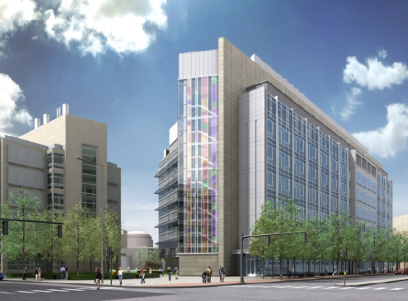

Figure 1.1
The building is primarily enclosed by an aluminum and glass curtain wall system. There is also a large amount of metal paneling accented by aluminum and stone coping. Detailed materials can be seen in the elevation Figure 1.2 (Left).
Building Enclosure
Roofing | EPDM (Ethylene Propylene  Diene Monomer)
Metal Paneling | Type 1, 2 & 3
Glazing
Type B | Vision
Type C | Opaque Spandrel
Type D | Shadowbox
Coping | Aluminum and Stone
Table 1.4

Figure 1.2

Sustainability Features
The Koch Institute for Integrative Cancer Research is designed to achieve LEED Gold certification. The design therefore includes a plethora of sustainable features both architecturally and within the building systems.
Architectural Sustainable Features
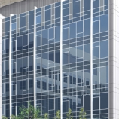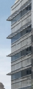
- Exterior Solar Shadings
- High Performance Glazing
- Light Shelves for Day lighting
- Enhanced Building Insulation

Building Statistics 2
Construction

Mechanical
The Koch Institute’s mechanical system is based on a central variable air volume 100% outdoor air concept. This system employs (8) 50,000 cfm factory built-up air handling units coupled with (8) equally sized exhaust air handling units to serve the labs and public spaces. Terminal hydronic space cooling and induction cooling terminals (chilled beam) are utilized to assist this system in high load interior zones as well as perimeter labs.
The vivarium spaces on level 7 are served by an additional (2) 50,000 cfm factory built-up air handling units, each with their respective exhaust air handling unit. To maintain proper cooling and space-pressure control of critical spaces on level 7, both constant and variable volume zones have been established.
Both systems utilize a heat pipe for energy recovery, transferring energy from the exhaust airstream to the entering airstream. This heat wheel provides pre-heating or pre-cooling of the entering airstream depending on the weather conditions.
Campus chilled water and high pressure steam enters through the basement and is then distributed to these systems throughout the building. A 200 ton water cooled rotary screw chiller provides redundant cooling capacity for the vivarium spaces. To provide spot cooling and stair pressurization there are 13 smaller air handling units ranging from 3600-9000 cfm throughout the building.
Electrical
The electrical utility is connected via an existing MIT manhole rated at 15 KV to a new manhole adjacent to the building. From the manhole, the service enters the basement in a concrete encased ductbank, which terminates in a pull box. The service is then fed to two double-ended substations (A & B) through G & W 15 KV two position load interrupting switches. Here the power is stepped down to 480Y/277 V through 2000 KVA frame size transformers and distributed throughout the building. Substation A also feeds optional standby receptacle and lab equipment loads through a 1600A 4 pole ATS as well as emergency lighting through a 400A 4 pole ATS. Substation B also feeds emergency and optional standby loads through 6 ATS’ of varying sizes. Emergency power is provided by a 2000KW/2500KVA diesel generator powering its own standby switchgear.

Lighting
The lighting of the Koch Institute is energy efficient, utilizing mainly linear fluorescent T5 and T8. The few exceptions to this general lighting design are public spaces, labs, MRI room and darkroom. Most public spaces located on the first level employ halogen sources to light the space. The labs, MRI room and darkroom all require special luminaires due to the nature of the work performed and the sensitivity of equipment within the space. All of these lighting systems are controlled by Lutron lighting control panels and dimmers. The control system uses photocells, occupancy sensors and time of day control to optimize the energy consumption of the system.
Structural
The superstructure of the Koch Institute employs individual steel columns ranging from W14x43 to W14x233. These columns tie into the orthogonal steel bracing system that provides lateral force resistance throughout the building. The substructure consists of concrete column footings, a foundation wall and slab on grade construction. The floor system is made up of 4.5” normal weight concrete on a 3” deep, 18 gage minimum composite steel deck. This floor system is supported by a beams and girders that vary in size due to the complexity of the layout and column spacing. The interior bays generally utilize W24x55 and W24x68 steel beams to carry the load to the girders. Exterior bays utilize W16x31 beams for the 26’-2” sections and W21x50 for the 30’-2” sections to carry the loads to the girders.
Fire Protection
The fire alarm system utilizes multiple ADA compliant audio/visual alarms. These alarms send out both a strobe and audio alert. The animal holding spaces use a chime tone indication differing from the rest of the system. A 125 horsepower fire pump supplies water throughout the fire protection system to maintain the prescribed flow rate (gpm) to all sprinkler heads. The fire pump receives its power through a 1600A 3 pole ATS that is fed by both Substation B and the Emergency Power Switchgear. This ensures that the pump will always have sufficient power in the case of an emergency.

Transportation
The building can be entered through vestibules leading to the lobby on both the North and South facades. Vestibules on the Northwest and Northeast corners of the building grant access into the gallery space and West and East stair shafts respectively. There are (2) passenger elevators which open to the lobby and rise from the basement to the sixth level. Adjacent to the passenger elevators is a service elevator and vivarium elevator that are not accessible from the lobby. These elevators are reached through vestibules on each floor, branching off of the northern corridor. The vivarium elevator terminates on level seven. The service elevator is the only of the four to span the entire length of the building, restricting access to the penthouse.
Telecommunications
The Koch Institute telecommunication service is fed into the basement through an existing manhole. The telecommunications is split into two zones and consists of a main distribution frame (MDF) in the basement and multiple intermediate distribution frames (IDF) located throughout the building. Each floor has and east and west IDF room providing telecommunications to its respective zone. Every IDF room receives data from a 48 strand armored singlemode fiber optic riser cable that is terminated at a rack mounted fiber panel. From the IDF rooms the data is distributed horizontally throughout the zone through (6) 4”conduits typ. providing telecommunications outlets.

